Mechatronics System Integration (MCTA3203)
Week 8: HuskyLensAI Vision and Real-Time Color Detection

HuskyLensAI Vision and Real-Time Color Detection

Objective:
By completing this lab, students will be able to:
- Interface a Gravity HuskyLens AI Vision Camera with an Arduino Uno using UART serial communication.
- Manually train an AI vision sensor to recognize predefined colors and objects.
- Parse serial data from an AI camera to trigger hardware responses.
- Control an HW-479 RGB LED module using PWM (analogWrite) to display specific color combinations based on AI data.

Required Hardware:
• Arduino Uno + USB cable
• Gravity HuskyLens AI Vision Camera
• HW-479 RGB LED Module / 3x Leds + 3x 220 ohm resistors
• Jumper wires and breadboard
Pre-Lab Software Configuration: Installing the HuskyLens Library
Before wiring the hardware or writing any code, you must install the official HuskyLens library into your Arduino IDE.
- Download the Library: Navigate to the official DFRobot HuskyLens GitHub repository (link in References). Click the green Code button and select Download ZIP. Save it to your Downloads folder. Do not unzip the file.
- Open the Library Manager: Launch the Arduino IDE. From the top menu bar, navigate to Sketch > Include Library > Add .ZIP Library...
- Import the ZIP File: Select the HuskyLens ZIP file you just downloaded and click Open.
Verify the Installation: Go to File > Examples. Scroll down to the "Examples from Custom Libraries" section at the bottom. You should now see a folder named HUSKYLENS.

Part 1: HuskyLens Setup and Basic AI Practice
Before we integrate complex logic, we must properly configure the HuskyLens to talk to the Arduino and practice a simple hardware trigger.

Experiment Steps:
1.1 Hardware Wiring
1.2 HuskyLens Protocol Configuration:
1.3 Practice 1: Serial Object Detection

1.1 Hardware Wiring
We will use SoftwareSerial to allow the Arduino to communicate with the camera while leaving the main hardware serial port (USB) free for our computer terminal.

HuskyLens Connections:
- VCC to Arduino 5V
- GND to Arduino GND
- TX to Arduino D4 (SoftwareSerial RX)
- RX to Arduino D5 (SoftwareSerial TX)

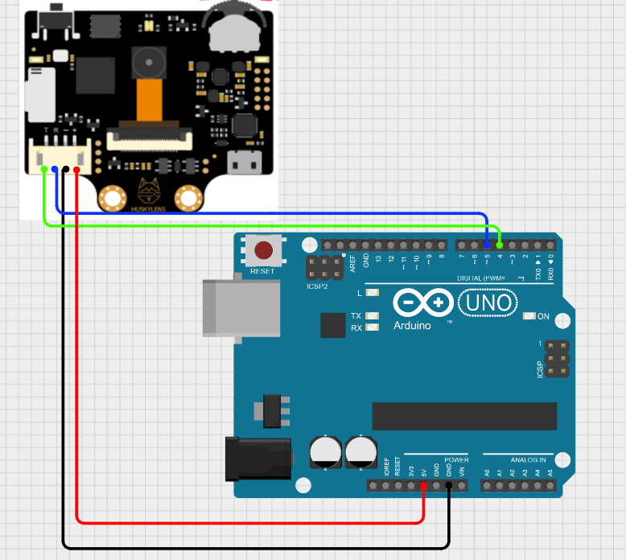
Circuit connection designed using cirkitdesigner

1.2 Crucial HuskyLens Protocol Configuration
By default, the HuskyLens might not be set to communicate via UART. You must manually configure its internal settings using the onboard buttons. You may refer to this :https://mm.digikey.com/Volume0/opasdata/d220001/medias/docus/422/SEN0305-S_Web.pdf

- Dial the Function Button (top wheel) to the left/right until you see "General Settings", then press down to select it.
- Dial to Protocol Type and press down.
- Dial to select Serial 9600 and press down.
- Dial to "Save & Return".

1.3 Practice 1 : Serial Object Detection
Train the HuskyLens to recognize a single object (like your hand or a phone). Upload the following code, open your Serial Monitor (set to 115200 baud), and point the camera at the object. You should see the Arduino printing the detection data in real-time.
Practice 1 Code:
#include "HUSKYLENS.h"
#include "SoftwareSerial.h"

HUSKYLENS huskylens;
SoftwareSerial mySerial(4, 5); // RX, TX

void setup() {
Serial.begin(115200);
mySerial.begin(9600);

// Wait for HuskyLens to connect
while (!huskylens.begin(mySerial)) {
Serial.println(F("Begin failed! Check wiring and Protocol (Serial 9600)"));
delay(500);
}
Serial.println("HuskyLens Ready!");
}

void loop() {
if (!huskylens.request()) return; // Skip loop if no data

// If the camera sees a trained object
if (huskylens.available()) {
HUSKYLENSResult result = huskylens.read();

// Check if the result is a standard object block
if (result.command == COMMAND_RETURN_BLOCK) {
Serial.print("Object ");
Serial.print(result.ID);
Serial.println(" detected!");
}
}
}
Run this code and open your Serial Monitor (set to 115200 baud). Point the camera at your trained objects and ensure the LED lights up and the ID prints to the screen!

Task 1: Object recognition control

Connect a standard LED to Digital Pin 13. Modify the Practice 1 code so that the LED turns ON when "Object 1" is detected, and turns OFF when the camera sees nothing. (Hint: You will need to use an else statement!).

Part 2: Multi-Color Recognition

The HuskyLens can track multiple distinct IDs at the same time. In this section, we will train it to recognize specific colors and use a switch statement to print different messages depending on which color it sees.

Experiment Steps:
2.1 Training 3 Colors
2.2 Practice 2: Color ID Serial Output:

2.1 Training 3 Colors
Using the HuskyLens interface, change the mode to "Color Recognition". Train the camera to recognize three specific colors in this exact order:
- ID 1: Red
- ID 2: Blue
- ID 3: Green

2.2 Practice 2: Color ID Serial Output
Upload the following code. When you point the camera at the trained colors, the Arduino will parse the incoming ID and print the specific color name to the Serial Monitor.

Practice 2 Code:
#include "HUSKYLENS.h"
#include "SoftwareSerial.h"

HUSKYLENS huskylens;
SoftwareSerial mySerial(4, 5); // RX, TX

void setup() {
Serial.begin(115200);
mySerial.begin(9600);

while (!huskylens.begin(mySerial)) {
Serial.println(F("Begin failed!"));
delay(500);
}
Serial.println("HuskyLens Color Recognition Ready!");
}

void loop() {
if (!huskylens.request()) return;

if (huskylens.available()) {
HUSKYLENSResult result = huskylens.read();

if (result.command == COMMAND_RETURN_BLOCK) {
// Evaluate the ID and print the corresponding color
switch (result.ID) {
case 1:
Serial.println("Color RED is detected");
break;
case 2:
Serial.println("Color BLUE is detected");
break;
case 3:
Serial.println("Color GREEN is detected");
break;
default:
Serial.println("Unknown Color detected");
break;
}
}
}
}

Task 2: Integrated RGB Color Display

Now for the final integration. You will replace the Serial Monitor outputs with physical lighting.
Combine your knowledge of Arduino PWM (analogWrite) with the switch statement from Practice 2
Hardware Addition: Connect the HW-479 RGB LED to the Arduino (if you have)
- GND to Arduino GND
- R (Red) to Arduino D9
- G (Green) to Arduino D10
- B (Blue) to Arduino D11
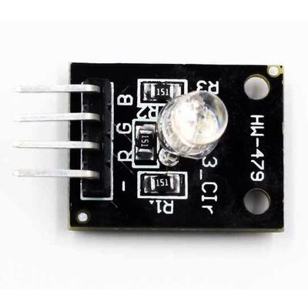
RGB LED - HW479

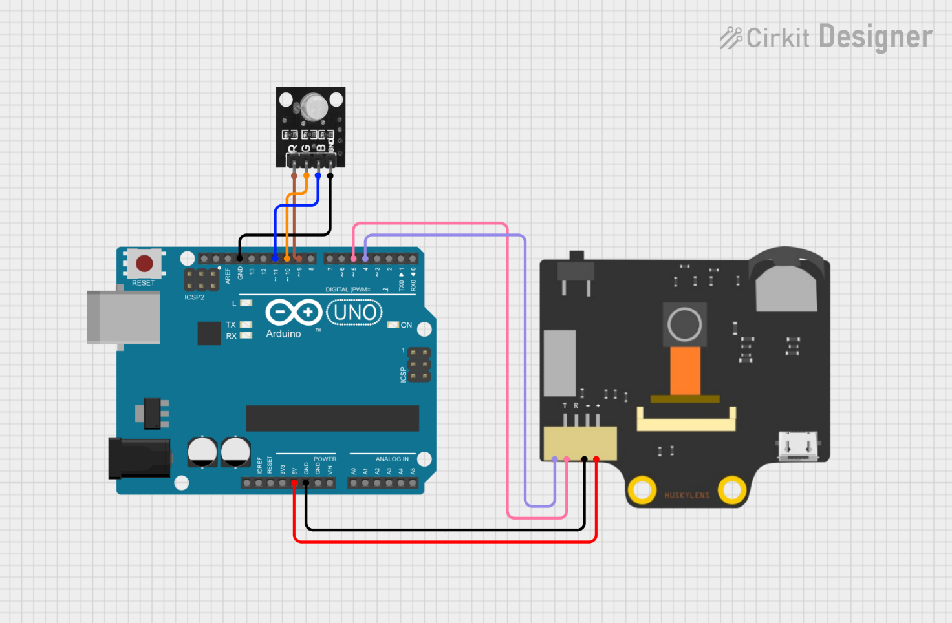
Schematic setup using Cirkit Software

- Train two additional colors on your HuskyLens: ID 4 (Yellow) and ID 5 (Purple). (optional)
- Write a new code where the RGB LED perfectly matches the color the camera is looking at.
(Hint: You will need to figure out the additive RGB values (0-255) to create Yellow and Purple!)

If you do not have the RGB LED, please use three different color LEDs. Note on the hardware setup for this:
If you are putting this in the manual as an alternative, be sure to remind the students that each individual LED requires its own 220 Ω resistor.
- Red LED Anode to D9 (Cathode to GND via resistor)
- Green LED Anode to D10 (Cathode to GND via resistor)
- Blue LED Anode to D11 (Cathode to GND via resistor)
Hint: Use digitalwrite
Submission Requirements:
1. Code Submissions (Source Files)
- Evaluation 1: Your completed .ino file for "The AI Light Switch" logic.
- Evaluation 2: Your completed .ino file for the "Integrated Color Display." (Note: If you used three individual LEDs instead of the RGB module, ensure your code reflects the digitalWrite logic rather than analogWrite).
2. Lab Report (PDF)
- Data Table: A table logging 5 trials containing the Actual Color presented, the Detected ID, and the final LED Output.
- Discussion: Explain how ambient lighting (brightness/shadows) affected the HuskyLens's accuracy during your testing and propose a method to fix or minimize this issue .
- Proof of Operation: A photo or video link showing the HuskyLens detecting a color (e.g., Yellow or Purple) while your LED setup simultaneously displays that exact color.

Troubleshooting Tips:

Issue | Potential Cause & Solution
fatal error: HUSKYLENS.h | The Arduino IDE cannot find the library. Return to the Pre-Lab Configuration section and ensure you imported the .ZIP file correctly via the Library Manager.
"Begin failed!" keeps printing | This is almost always a protocol or wiring mismatch. Ensure your jumper wires are crossed (HuskyLens TX to Arduino RX, and HuskyLens RX to Arduino TX). Next, physically check the HuskyLens screen settings to ensure Protocol Type is explicitly set to "Serial 9600”.
Camera detects the wrong color | AI vision relies heavily on ambient lighting. If you trained the color in a bright room and test it in a dim room, the AI sees a different color. Delete the trained IDs and re-train the camera under your current lighting conditions.
LED colors are mixing incorrectly | Check your wiring. If using an RGB module, ensure you are plugged into PWM-capable pins (the ones with a ~ symbol). If using 3 discrete LEDs, double-check that your HIGH/LOW logic is targeting the correct pins for combinations like Yellow (Red + Green) or Purple (Red + Blue).

References

- https://github.com/HuskyLens/HUSKYLENSArduino
- https://www.youtube.com/watch?v=HZxFj2u9k00Arduino and HC-05 Bluetooth Module Complete Tutorial
- https://drive.google.com/file/d/1FobcfurW-JiH7lUpDhGipDavSHsuWPXZ/view?usp=sharing
- https://my.cytron.io/tutorial/getting-started-with-huskylens-and-arduino

